PRACTICAL 4

Q. CREATE A SIMPLE WEB SERVER USING RASPBERRY PI

sudo apt update: Updating our system before creating the server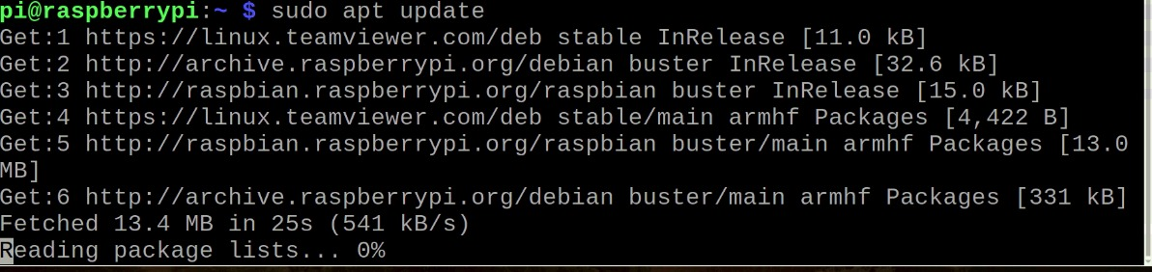

sudo apt-get install apache2 -y: Installing apache onto our system

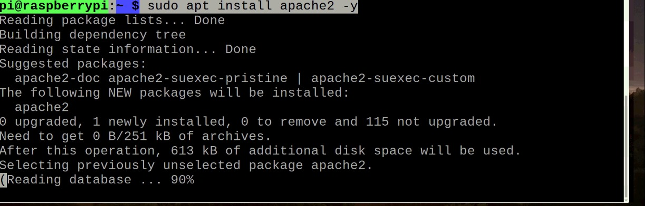

service apache2 start: Checking if apache has been installed onto our system

service apache2 status: Checking for the status of Apache server

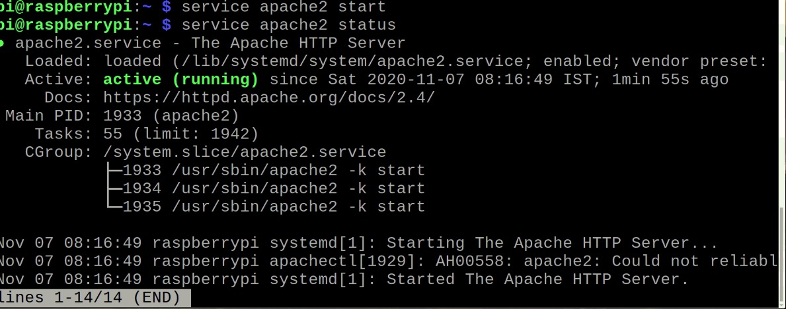

Now we create a HTML document with the name index.html

sudo rm/var/www/html/index.html: Removing our existing index.html file from the folder /var/www/html

sudo cp Desktop/index.html /var/www/html: Copying our newly created HTML document namely index.html into the folder /var/www/html/

ifconfig: Next check for the ip address

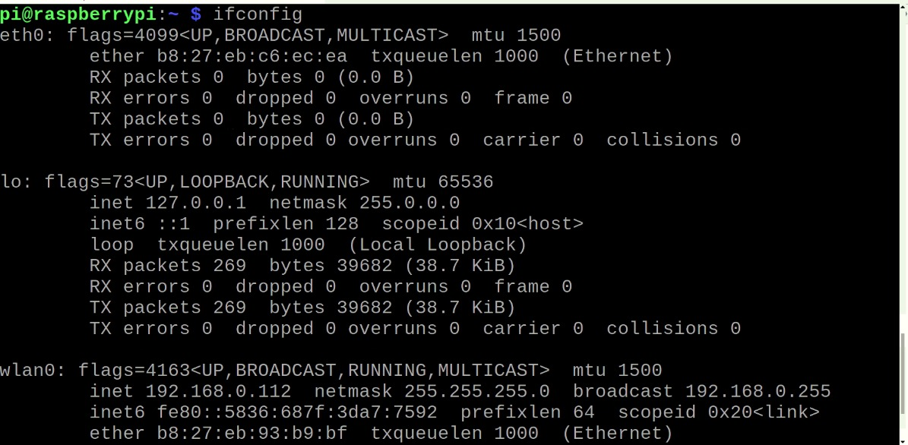

Finally, put the ip address into any remote browser and your web server is ready!